Golden Layer Cake
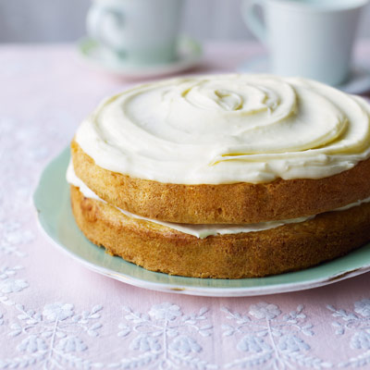
Ingredients:
2 ¼ cups flour
1 ½ cups sugar
3 teaspoons baking powder
1 teaspoon salt
½ cup shortening
1 cup milk
1 ½ teaspoons vanilla
2 eggs

Directions:
Preheat oven to 350° F. Grease and flour and 13X9 baking pan. Measure all ingredients into a large mixing bowl. Blend ½ minute on low speed, scraping the bowl constantly. Beat 3 minutes on high speed, scraping the bowl constantly. Pour into prepared pan.
Bake for 40-45 minutes or until a toothpick inserted into the center comes out clean. Cool.

